Ein Bild, das Konzert, Klavier, Mikrofon, Musiker enthält.
Ein Bild, das Elektronik, Tastatur, Computer, Screenshot enthält.
*Lara Grogan*

* 6 Fun Facts about Lara
* 6 Stepping Milestones
* Press & Radio (Articles & Interviews)

1. ***Fun Facts about Lara***

**Joni Mitchell, The Beatles, Simon & Garfunkel, Carole King, Beethoven, Tchaikovsky**

These artists and composers shaped Lara’s musical world from an early age.

**Storytelling & Authenticity**

Every song Lara writes feels like building a small world: imaginative, thoughtful, and emotional.

**Pop, Folk, Rock, Classical**

Blending genres and instruments helps Lara create a sound of her own. She performs *folk-rock* with a full band and *intimate singer-songwriter* sets as a duo with a cellist.

**Plurilingual**

Lara speaks five languages, with English as her mother tongue. She grew up in multilingual Luxembourg, attending school in Luxembourgish, German, and French. As a teenager, she also studied Latin and earned hes Kleines Latinum.

**Multicultural**

Lara was born in Luxembourg in 2004 to an English-speaking father from South Africa and a Russian-speaking mother from Moldova. She grew up surrounded by languages, cultures, and music. Both her parents are translators and music lovers.

**A True Lover of Books**

Lara loves reading, and stories often inspire her songwriting. At 14, she wrote *What Was Mine* after reading the Greek myth *Echo and Narcissus*, and at 15, *The Sculptor* was born after reading *Vom Ende der Einsamkeit* by Benedict Wells.

***6 Stepping Milestones***

**2024**  
Released debut album *The Sculptor*, featuring 8 songs written between ages 14 and 18. Composed and arranged string quartet parts.

**2023**  
Title track *The Sculptor* became a Semi-Finalist in the Singer-Songwriter category of the UK Songwriting Contest.

**2022**  
Composed and performed *City and Its People* (age 18) for the opening of Esch 2022, European Capital of Culture.

**2017**  
Youngest participant (age 13) in the first Screaming Fields Song Contest organized by Rocklab / Luxembourg. Song ranked among the top five entries.

**2015**  
First stage performance at school (age 11), holding an electric guitar and singing a Beatles song in front of classmates and parents.

**2013**  
Started piano lessons at age 9 and picked up guitar two years later at age 11.

***Press & Radio***

|  |  |
| --- | --- |
| WORT.LU (19.11.2025) in German  Wor | WORT.LU (14.03.2025) in German    <https://www.wort.lu/kultur/zwischen-mythen-und-melodien-lara-grogan-vertont-luxemburger-legenden/48958356.html> |

LEQUTIDIEN.LU (20.03.2025) in French

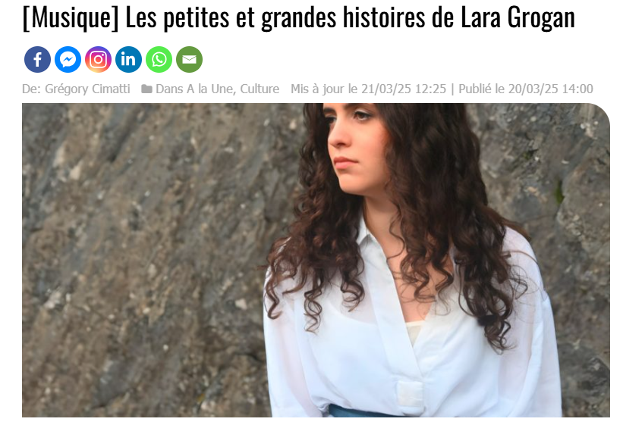

Link: <https://lequotidien.lu/a-la-une/musique-les-petites-et-grandes-histoires-de-lara-grogan/>

|  |  |
| --- | --- |
| WORT.LU (25.04.2024) in German  <https://www.wort.lu/kultur/lampenfieber-und-leidenschaft-lara-grogan-strebt-karriere-als-singer-songwriterin-an/12235912.html> | WORT.LU (27.04.2024) in German  <https://www.wort.lu/kultur/lara-grogan-mit-elf-ihr-erstes-lied-mit-20-ihr-erstes-album/12306081.html> |
| CHRONOCLE.LU (19.06.2024) in English  <https://chronicle.lu/category/music/50306-young-luxembourg-musician-lara-grogan-launches-debut-album-the-sculptor> | FEMMESMAGAZINE.LU (16.07.2024) i n French  <https://www.femmesmagazine.lu/la-musique-comme-horizon/> |

**Interviews on RADIO**

**100,7**

* 27.04.2024 / In Luxembourgish: ***Den éischten Album vun der Lara Grogan*** (Title in English: Lara Grogan’s debut album)
* 26.04.2024 / In Luxembourgish: ***D’Lara Grogan bréngt hiren éischten Album*** *eraus* (Title in English: Lara Grogan releases her debut Album*)*
* 27.09.2023 / in Luxembourgish: ***Kultur em 5*** (Title:Lara Grogan releases a new song,“The Sculptor”). About the release of the song *“The Sculptor”)*
* 18.07.2023 / in Luxembourgish: ***Wann aus Mythologie Musek gett*** (T*itle: When mythology becomes music (*about the release of the song *“What was mine”)*

**SR.DE**

19.03.2025 / In German: ***Songs inspiriert von luxemburgischen Märchen*** (Title in English:Songs inspired by Luxembourgish fairy tales)

Links

|  |  |
| --- | --- |
| Une image contenant texte, capture d’écran, Police  Le contenu généré par l’IA peut être incorrect.  Radio 100,7(26.04.2024 / in Luxembourgish)  Title:  Listen to the interview HERE  <https://m.100komma7.lu/episoden/D-Lara-Grogan-brengt-hiren-eischten-Album-eraus?pd=radio> | Une image contenant texte, capture d’écran, Police, Page web  Le contenu généré par l’IA peut être incorrect.  Radio 100,7(27.04.2024 / in Luxembourgish)  Title: *Lara Grogan’s debut album*  Listen to the interview HERE  <https://m.100komma7.lu/episoden/Den-eischten-Album-vun-der-Lara-Grogan?pd=radio> |
| Une image contenant texte, capture d’écran, Police, nombre  Le contenu généré par l’IA peut être incorrect.  Radio 100,7 (27.09.2023 / in Luxembourgish)  Title: *Lara Grogan releases a new song, “The Sculptor”*  Listen to the interview HERE  <https://www.100komma7.lu/episoden/Kultur-um-5-623688429?pd=radio> | Une image contenant texte, capture d’écran, Police, nombre  Le contenu généré par l’IA peut être incorrect.  Radio 100,7 (18.07.2023 / in Luxembourgish)  *Title: When mythology becomes music (about the release of the song “What was mine”)*  Listen to the interview HERE  <https://api.100komma7.lu/program/episode/450734/20230718082200-20230718082700?pd=radio> |